Spot User Manual

**Installation**:

First the user must make sure that they can use WiFiDirect on their Android phone. The WiFiDirect protocol was introduced in Android 4.2 so the user must be using at least Android 4.2 KitKat or greater. To install and run the app, plug your android phone into a computer running our Code in eclipse, and click run as. Choose your device, and the app will now install and launch on your phone.

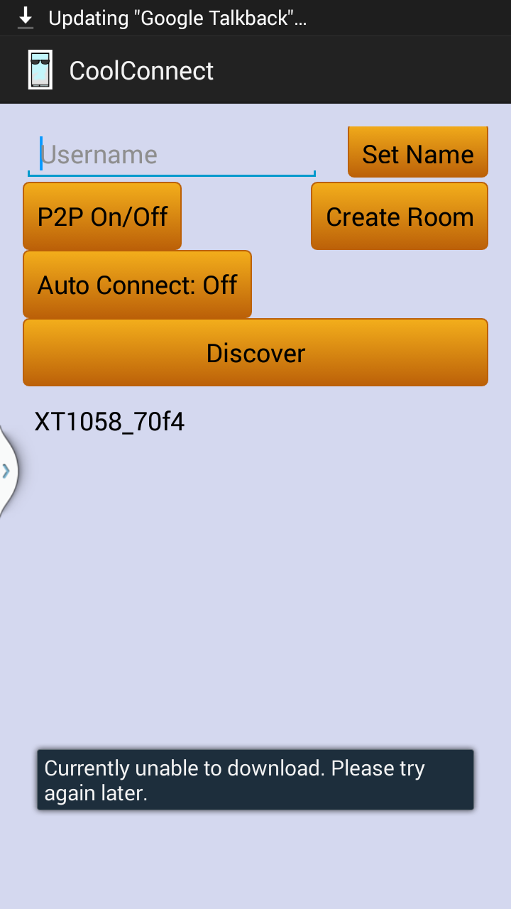

**Setup**:

When the app is launched the app with automatically discover all nearby users that you can connect to. You should set your username first before connecting to a room because the default username is chad. The app will require WiFi to be enabled: a settings button called P2P ON/OFF is available to take you to the WiFi settings in order to do that. To connect to a chat, click on any user, which is any name underneath the discover button. If you don’t discover any users, you can select the “Create Room” button which will initiate a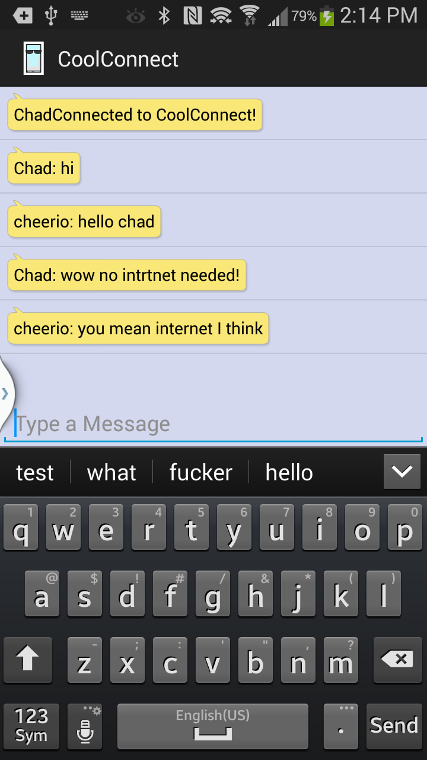 new chat.

**Chat**:

Once you are in a chat, you will be able to send and receive messages with all other nearby users of CoolConnect. The connection range is about 200m. Whenever a new user joins the room, you will receive a message that they have connected to CoolConnect. Type a message into the text box and press the send button to send a message. If a message fails to send, don’t worry, the app will automatically retry for you for up to 30 seconds before it gives up. Press the back button to exit the app. *It is currently recommended that you turn Wi-Fi off and on on your phone after exiting CoolConnect in order to preserve your phone’s battery life.*

Quick Reference

Create: Creates a group using the user specified name.

Discover: Looks for nearby users.

P2P On/Off: Opens the phones’ network settings so wifi options can be changed.

Auto Connect: Toggles wether or not CoolConnect should automatically connect to any users it encounters.